GLOBAL ENERGY TRANSITION
& Market Reliability

Data Visualisation Project Report
United Kingdom · United States · Australia
Coverage: 2019–2025 (Australia: 1999–2025)
Farzan Momayezi – Student ID:33658285 – Tutor: Ashwini Narasimhan – Applied 14

1. Introduction
The global electricity sector is undergoing its most significant structural transformation since electrification. Solar and wind generation capacity are growing at unprecedented rates, yet their intermittent nature raises fundamental questions about grid reliability and market stability. This project investigates those questions through a comparative analysis of three national electricity grids — the United Kingdom, the United States, and Australia — which represent three distinct stages and approaches to the energy transition.

The United Kingdom has pursued a deliberate coal phase-out, completing it in September 2024, while expanding offshore wind to cover over 30% of annual generation. The United States operates the world's largest electricity market with significant regional diversity, transitioning more slowly due to structural inertia and political variation. Australia, heavily dependent on coal historically, has experienced one of the fastest renewable buildouts globally, driven by exceptional solar resources and competitive market incentives.

Three research questions guide the investigation:

- RQ1 — Transition Velocity: Between 2019 and 2025, which country moved away from fossil fuels (Coal + Gas) fastest? The speed of fossil decline is compared against Wind and Solar growth across all three grids to identify the most aggressive transitioner.
- RQ2 — Grid Stress-Testing: During peak demand periods — winter nights in the UK, summer heatwaves in Australia, and summer heat in the US — when renewable output is low, which backup sources fill the gap, and how fossil-dependent does each grid become under stress?
- RQ3 — Market Volatility: Does a higher share of variable renewables (Wind + Solar) make wholesale electricity prices more volatile? Statistical measures (Standard Deviation, Coefficient of Variation) are applied to the Australian wholesale market — the only dataset with price data — spanning 1999 to 2025.
- RQ4 — Portfolio Diversification: Is the energy transition making electricity grids structurally more diverse and resilient, or simply replacing one dominant fuel with another? The Herfindahl-Hirschman Index (HHI) — a concentration metric from economics — is applied to each country's monthly generation mix to quantify portfolio diversity over time.

The motivation for this work is practical: policymakers, investors, and grid operators need evidence-based answers to these questions as they design transition pathways. The analysis combines three publicly available datasets, processed through a four-stage R pipeline, and visualised using interactive Shiny dashboards.

2. Data Wrangling and Checking

2.1 Data Sources
Three national-level datasets were obtained from official grid operators and energy statistics agencies:

Dataset | Country | Provider | URL | Granularity | Coverage
gridwatch.csv | UK | GridWatch / National Grid ESO | gridwatch.templar.co.uk | 5-minute | 2019–2025
US Energy generation dataset.csv | USA | EIA Hourly Grid Monitor | eia.gov/electricity/gridmonitor | Daily | 2019–2025
19990101 All Regions Australia.csv | AU | AEMO / OpenNEM | opennem.org.au | Monthly | 1999–2026

Raw file sizes were substantial: the UK GridWatch file contained 734,336 rows, the US EIA production file 5,048,813 rows, and the Australian AEMO file 326 rows. Together, these represented over 5.7 million records before processing.

2.2 Data Wrangling Pipeline
A four-script R pipeline was developed using tidyverse, lubridate, and janitor. Each script handles one country and outputs a standardised monthly CSV; the fourth script combines all three.

Pipeline: 01_clean_uk.R → 02_clean_us.R → 03_clean_australia.R → 04_combine.R
Output: uk_monthly.csv | us_monthly.csv | au_monthly.csv → combined_energy.csv

United Kingdom — GridWatch
- Leading whitespace: All 734,336 timestamp values contained a leading space character (' 2019-01-01 00:00:36'). This caused silent NA production in all datetime parsers until str_trim() was applied before ymd_hms().
- Data gaps: 13 gaps exceeding one hour were identified by computing consecutive timestamp differences. The largest gap was 72.3 hours in March 2025. These were documented as known limitations rather than imputed, as monthly aggregation reduces their impact to below 0.5%.
- Sensor dropouts: 2,888 rows recorded frequency = 0.000 Hz — physically impossible on the UK grid (nominal 50 Hz). These rows were retained since generation data remained valid; the frequency column was excluded from all analysis.
- Gas technology merger: The raw data splits gas into ccgt (Combined Cycle, baseload) and ocgt (Open Cycle, peaking). Both were recoded to 'Gas' after pivot_longer() to match the single NG code used by the US EIA.
- Unit conversion: Each 5-minute MW instantaneous reading was converted to GWh using: GWh = MW × (5 ÷ 60) ÷ 1,000, then summed monthly.

United States — EIA
- Scale: The production file contained 5,048,813 rows — five times the development sample of 1,055,000 rows.
- readr type coercion bug: The period column ('2019-01-01' format) was silently coerced to a Date object by readr before mutate() was called, causing ymd_h() and parse_date_time() to fail with 'All formats failed to parse.' Fix: col_types = cols(period = col_character()) at read time, plus as.character() as a defensive cast.
- Duplicate rows: 4,029,404 rows (79.8%) were duplicates arising from overlapping utility-level and pre-aggregated regional records. These were collapsed by group_by(country, date, source) |> summarise().
- Negative values: 151,492 rows carried negative generation values representing battery charging, pumped hydro charging, and grid imports. These were removed with filter(value >= 0).
- Unmapped fuel codes: 7 new EIA codes (BAT, SNB, PS, OES, WNB, UNK, UES) representing hybrid storage technologies were absent from the original fuel_map dictionary. These were mapped to appropriate categories (Other, Solar, Hydro, Wind).
- Unit conversion: EIA values are in MWh. Divided by 1,000 to produce GWh, then summed monthly.

Australia — AEMO / OpenNEM
- Structural zeros: Solar (zero before 2016), Wind (zero before 2009), and Bioenergy (zero before 2009) carried zero values in early years — not missing data, but correct records of zero generation before deployment. Retained as valid data points.
- Negative generation: 6 rows held negative generation_gwh from pumped storage charging periods. Removed in the combine step with filter(generation_gwh >= 0).
- Price missing marker: The 'Volume Weighted Price - AUD/MWh' column used 0 as a missing-value marker in years with sparse reporting. Zero values were replaced with NA before any price analysis.
- No unit conversion required: The AEMO file is already monthly GWh.

2.3 Cross-Country Harmonisation
- Units: All three datasets were standardised to GWh per month.
- Source vocabulary: 12 standardised source labels were defined. CCGT + OCGT → Gas. Pumped storage → Hydro. EIA codes mapped to readable names.
- Renewable flag: A boolean renewable column was added: TRUE for Wind, Solar, Hydro, Bioenergy, and Biomass.
- Scale disparity: The US generates ~260× more electricity than the UK or Australia. All cross-country comparisons therefore use percentage share of total generation, not absolute GWh.
- Date filter: The combined dataset uses 2019–2025 as the common window. Australia's full 1999–2025 data is retained separately for RQ3 price analysis.

2.4 Data Quality Verification
Check | UK | US | AU | Combined
Null values | 0 | 0 | 0 | 0
Negative GWh (post-filter) | 0 | 0 | 0 | 0
Date range correct | Yes | Yes | Yes | Yes
Expected row count | 504 | 686 | 2,268 | 1,778
All sources present | 6 | 9 | 7 | 12
Renewable flag coverage | N/A | N/A | N/A | 1,778/1,778

All checks passed after the wrangling pipeline. The combined dataset is fully clean with zero nulls, no negative values, correct date coverage, and consistent source vocabulary across all three countries.

3. Data Exploration
The exploration was conducted in three phases, one per research question, using R Shiny dashboards with plotly visualisations. The choice of interactive dashboards was deliberate: electricity data is highly seasonal and multi-dimensional, and static charts cannot adequately support the filtering and drill-down needed to examine patterns across countries, years, and source types simultaneously. All tools used were R, plotly, bslib, lubridate, tidyverse, and the slider package for rolling windows.

3.1 RQ1 — Transition Velocity

Objective and design rationale
Question: Between 2019 and 2025, which country moved away from fossil fuels (Coal + Gas)
fastest, and which grew Wind + Solar the quickest?

- What we are looking for: The rate of change in the generation mix — not just the current level, but how fast each country is moving. A country at 60% fossil declining by 0.3 pp/month is transitioning faster than one at 40% declining by 0.1 pp/month, even though the latter has a cleaner grid today.
- How we measure it: Monthly percentage share of Coal + Gas ('fossil share') and Wind + Solar ('W+S share') are computed for each country. Linear regression (lm() in R) is fitted to each time series, producing a slope coefficient in percentage points per month — the 'transition velocity.' This single number is directly comparable across countries regardless of grid size.
- Why percentage share, not absolute GWh: The US generates ~260× more electricity than the UK or Australia. Without normalising to percentages, the US dominates every absolute chart and meaningful comparison is impossible.
- Why line charts with trend overlay: Time series line charts (Figures 1–4) show both the raw monthly data and the fitted regression line. The raw line reveals seasonal volatility; the dashed trend line isolates the underlying direction. Bar charts cannot show continuous temporal trends; scatter plots would lose the time axis.
- Why a slope comparison bar chart: Figure 5 translates the regression slopes into a grouped bar chart — enabling direct side-by-side comparison of a single scalar metric (pp/month) across countries. The zero reference line distinguishes decline from growth.
- Why a dumbbell chart: The dumbbell plot (in dashboard) shows start-year and end-year values as connected dots. It answers 'how far did each country travel?' rather than 'how fast?' — complementing the slope chart with absolute magnitude.

Approach and justification
Percentage share of monthly generation was chosen as the primary metric rather than absolute GWh, because the US generates approximately 260 times more electricity than the UK. Without normalisation, visual comparison is impossible. Linear regression was applied to each country's monthly fossil share and Wind+Solar share time series, producing a slope coefficient (percentage points per month) as the 'transition velocity' — a single comparable number per country.

Visual analysis — fossil share decline
Figure 1 plots the monthly fossil (Coal + Gas) share of generation for all three countries from January 2019 to December 2025. The raw monthly lines reveal the volatility that trend lines alone would hide: Australia's share fluctuates seasonally around a clear downward trajectory, the UK exhibits sharp month-to-month swings driven by wind variability, and the US moves within a tight band around 55–65%, confirming its structural inertia.
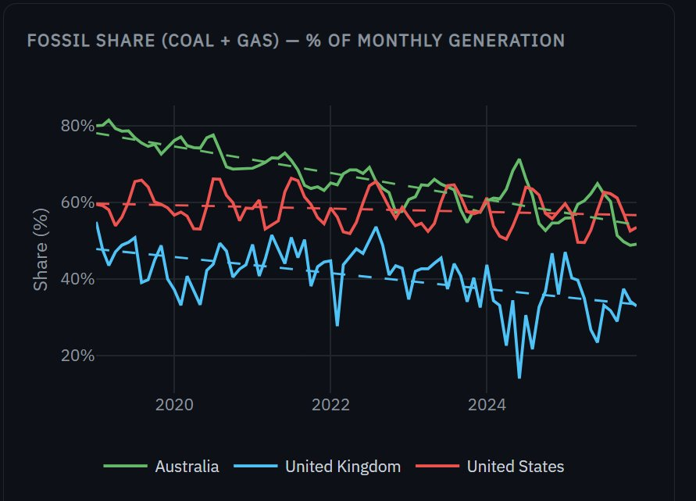
Figure 1. Monthly fossil share (Coal + Gas) across UK, US, and Australia, 2019–2025. Dashed lines show linear regression fits. All three countries show declining trends, but Australia's slope is visibly steepest.
Figure 2 isolates the linear regression fits from Figure 1, making the relative speeds of decline visually unambiguous. Australia's trajectory crosses the US line in 2024 — despite starting ~17 percentage points above it in 2019. The UK sits on a parallel lower path, reflecting its earlier coal exit.
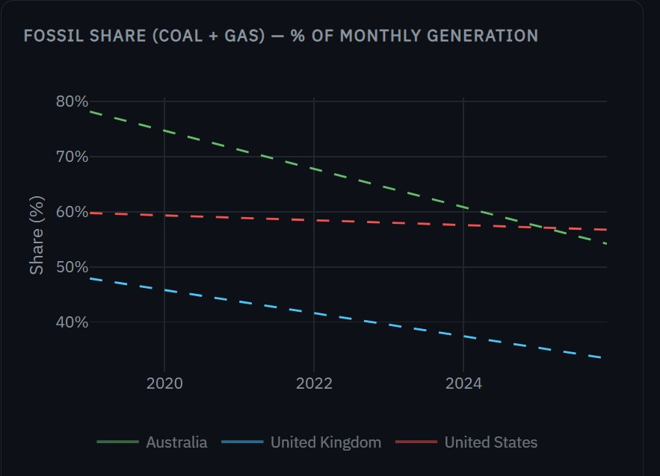
Figure 2. Linear regression fits only — fossil share trend lines for UK, US, and Australia, 2019–2025. Australia (green) shows the steepest decline, crossing below the US (red) by 2024.

Visual analysis — Wind + Solar growth
Figure 3 shows the corresponding trend lines for Wind + Solar share. The three paths are nearly parallel in slope — but at very different levels. The UK and Australia both approach 40% Wind+Solar by 2025, while the US reaches only 18%. Critically, Australia's slope matches the UK's despite starting 7 percentage points lower.
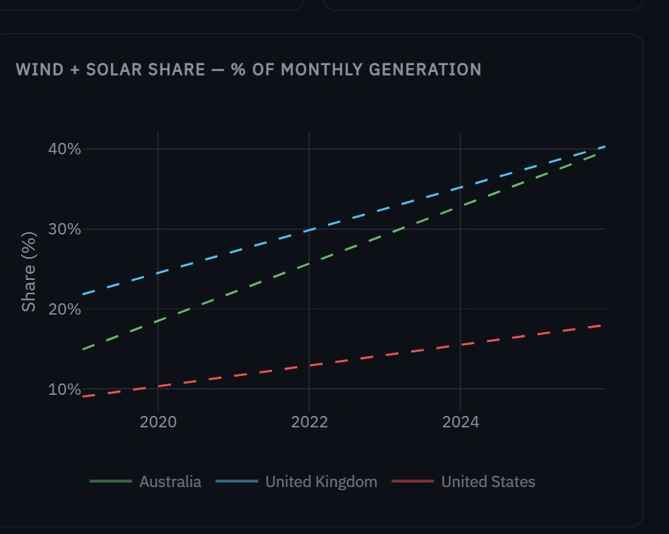
Figure 3. Wind + Solar share — trend lines only. UK and Australia follow near-parallel growth paths reaching ~40% by 2025; the US trails at ~18%.
Figure 4 overlays the raw monthly data on the trend lines. The UK's extreme month-to-month variability — spikes above 50% in some months, dips below 20% in others — demonstrates wind intermittency. Australia's seasonal pattern is more regular, reflecting the stable solar resource base.
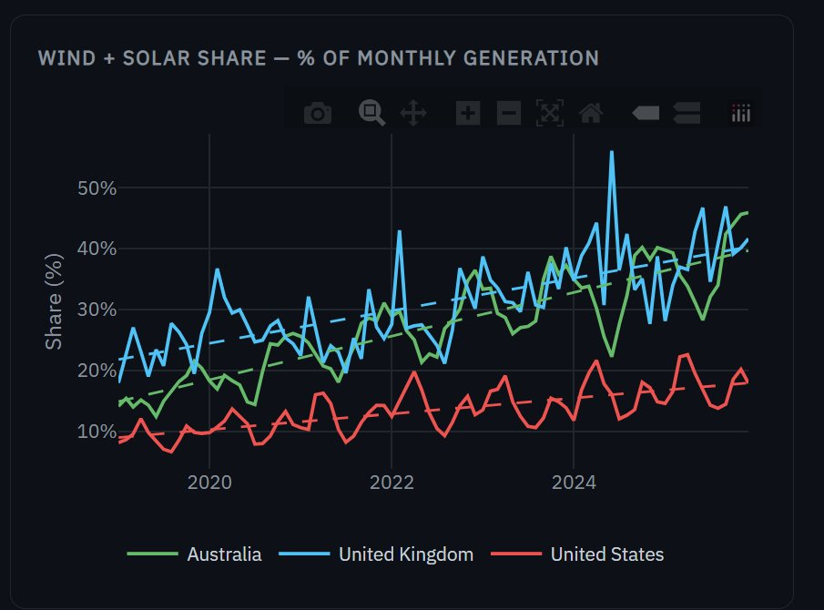
Figure 4. Wind + Solar share with raw monthly data. UK shows extreme month-to-month volatility reflecting wind intermittency; Australia exhibits a smoother seasonal pattern driven by solar.

Visual analysis — transition velocity comparison
Figure 5 distils the regression results into a single direct comparison. The bar heights are the slope coefficients from the linear regressions in Figures 1–4. Australia's fossil decline (−0.289 pp/month) is roughly 1.7× faster than the UK's and 8× faster than the US's. Australia also has the strongest Wind+Solar growth (+0.298 pp/month). The symmetry between the bars within each country is striking — the fossil energy being displaced is being replaced almost one-for-one by variable renewables.
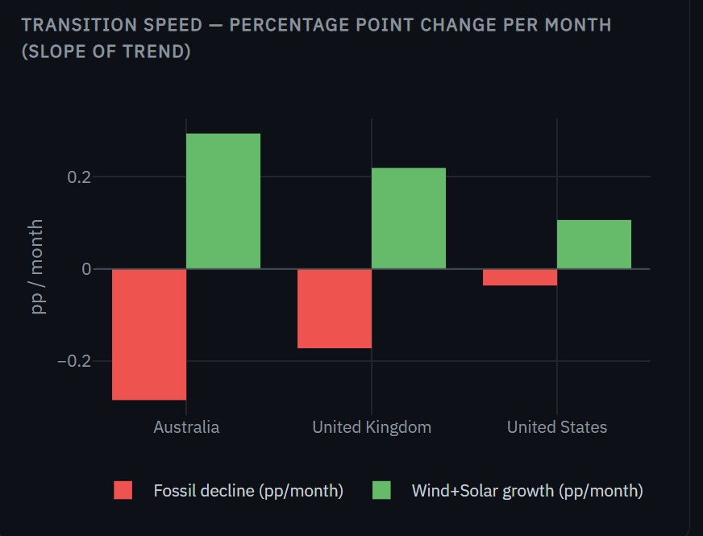
Figure 5. Transition speed comparison — linear regression slope (percentage points per month) for fossil decline (red) and Wind+Solar growth (green). Australia is the fastest transitioner on both metrics.

Key findings
Country | Fossil 2019 | Fossil 2025 | Δ Fossil | Slope (pp/mo) | W+S 2019 | W+S 2025 | Δ W+S | Slope (pp/mo)
Australia | 77.3% | 56.8% | -20.5 pp | -0.289 | 16.4% | 37.7% | +21.4 pp | +0.298
United Kingdom | 46.3% | 34.2% | -12.1 pp | -0.175 | 23.2% | 39.1% | +15.9 pp | +0.223
United States | 60.1% | 56.4% | -3.7 pp | -0.036 | 9.2% | 17.7% | +8.5 pp | +0.108

- Australia fastest transitioner: Australia recorded the steepest fossil decline slope (−0.289 pp/month) and the largest absolute shift of any country (−20.5 pp fossil, +21.4 pp Wind+Solar). Crucially, Australia started from the highest fossil base (77.3% in 2019), demonstrating that even a deeply coal-dependent grid can transition rapidly with the right policy and resource conditions.
- UK steady and structural: The UK's transition predates the study window — it entered 2019 already at 46.3% fossil, having exited coal years earlier. Its slope (−0.175 pp/month) reflects a mature, ongoing transition rather than a sudden shift.
- US structural inertia: The US moved slowest on both metrics (−0.036 pp/month fossil decline). The scale and diversity of the US grid — 81 utility respondents, large coal-dependent regions — create structural barriers that aggregate statistics mask.
- Coal absence in UK: Coal does not appear in the UK processed dataset — a real-world finding, not a data gap. Great Britain's last coal plant closed in September 2024.

Additional visual analysis — RQ1
Figure 6 presents the dumbbell chart showing the start (2019, orange) and end (2025, pink) fossil share for each country. The length of each connecting line represents the total magnitude of change. Australia's line is the longest — stretching from 80% to 55% — confirming it achieved the largest absolute fossil reduction. The US's line is barely visible, with start and end points nearly overlapping at 58–60%.
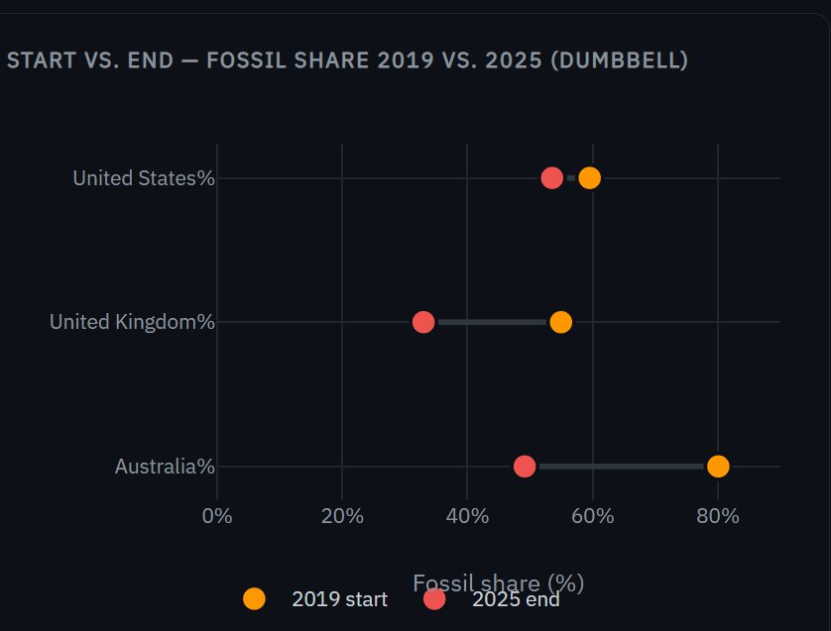
Figure 6. Dumbbell chart — fossil share start (2019) vs. end (2025). Line length = magnitude of transition. Australia achieved the largest absolute shift; US shows minimal movement.
Figure 7 shows the annual grouped bar charts for fossil share (left) and Wind+Solar share (right) side by side. The bars make year-on-year changes directly readable. Australia's green bars decline consistently from left to right in the fossil panel and rise consistently in the Wind+Solar panel. The UK follows a similar pattern but from a lower starting point. The US bars are nearly uniform in height — confirming that its annual shifts are marginal.
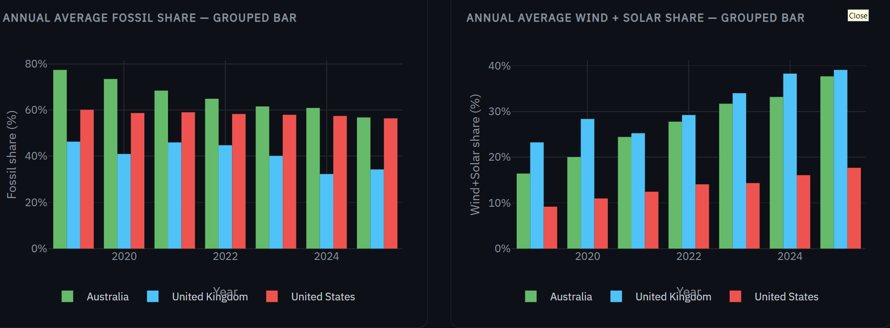
Figure 7. Annual average fossil share (left) and Wind+Solar share (right) — grouped bar charts. Australia and UK show clear year-on-year improvement; US remains structurally flat.
Figure 8 reveals the internal composition of fossil generation through a stacked area chart faceted by country. In Australia (left), Coal (grey) dominates but is shrinking visibly, while Gas (brown) remains a thin stable layer. In the UK (centre), the fossil share is almost entirely Gas — Coal is absent because Britain completed its coal phase-out during this window. The US (right) shows a roughly equal Coal-Gas split with modest year-on-year narrowing. This chart demonstrates that the 'fossil decline' captured in RQ1 is driven by different fuels in different countries — Coal in Australia, Gas in the UK, and a slow Coal erosion in the US.
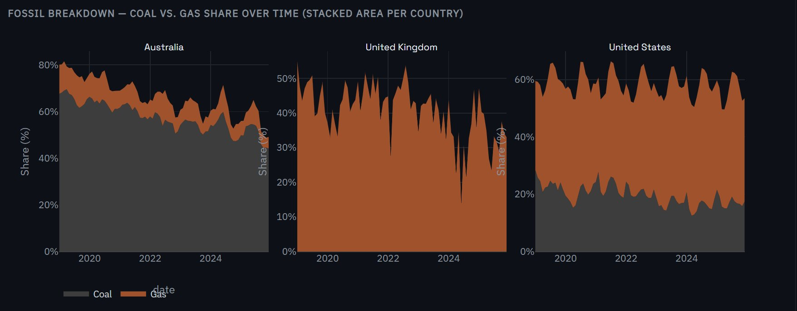
Figure 8. Fossil breakdown — Coal vs. Gas share over time (stacked area per country). Australia's decline is Coal-driven; UK is Gas-only (no Coal); US shows slow Coal erosion with stable Gas.

Visualisations used for RQ1
- Fossil share line charts (Figures 1–2): Monthly time series showing raw data with dashed linear regression trend overlaid. Figure 1 includes raw monthly volatility; Figure 2 isolates the trend lines for direct slope comparison. Line charts were chosen because continuous temporal trends are the key quantity of interest — bar charts cannot represent monthly flow.
- Wind+Solar share line charts (Figures 3–4): Same structure as the fossil charts but tracking renewable growth. Figure 3 shows trend-only for clean comparison; Figure 4 adds raw data to reveal UK wind intermittency and Australia's smoother solar-driven pattern.
- Transition speed bar chart (Figure 5): Grouped bar chart comparing regression slopes (pp/month) for fossil decline and W+S growth. Enables direct side-by-side comparison of a single scalar metric across countries. The zero reference line visually separates decline from growth.
- Dumbbell chart (Figure 6): Start (2019) and end (2025) fossil share as connected dots per country. Line length encodes the magnitude of change — complementing the slope chart which encodes speed. Chosen because it answers 'how far?' while the slope chart answers 'how fast?'
- Annual grouped bar charts (Figure 7): Two-panel display of annual average fossil share (left) and W+S share (right). Bars make discrete year-on-year changes directly readable, which continuous line charts obscure. Grouped layout enables cross-country comparison within each year.
- Fossil breakdown stacked area (Figure 8): Coal vs. Gas share over time, faceted by country. Stacked area idiom was chosen because it shows both the total fossil share (top edge) and the internal composition (Coal vs. Gas boundary) simultaneously. Reveals that Australia's decline is Coal-driven while UK's is Gas-only.

3.2 RQ2 — Grid Stress-Testing

Objective and design rationale
Question: During periods of peak demand when renewable output is low, how does each grid
survive? Which backup sources fill the gap?

- What we are looking for: The 'reliability gap' — how much the renewable share of generation drops during peak-stress months compared to normal months. A large gap means the grid becomes significantly more fossil-dependent under stress, revealing structural vulnerability.
- How we define peak stress: Each country has a different climate-driven peak: UK winters (Dec–Feb) when solar is near zero and heating demand peaks; Australian summers (Dec–Feb) when extreme heat drives air-conditioning load; US summers (Jun–Aug) when heat waves stress southern and central grids.
- How we measure it: Renewable share is computed separately for peak and non-peak months, then the difference (non-peak minus peak) gives the reliability gap in percentage points. The backup source mix is computed as each source's share of total generation during peak months only.
- Why donut charts for backup mix: Figure 9 uses donut charts because the question is 'what fraction of the whole does each source contribute?' — a part-of-whole composition question that donuts make instantly readable. Stacked bars would work but are harder to compare when the totals differ.
- Why a gap line chart: Figure 10 plots the reliability gap annually as a line chart. A line was chosen because the key insight is the trend — is the gap widening or narrowing? The zero reference line provides the interpretive threshold.
- Why a scatter with peak highlighting: In the dashboard, monthly dots are plotted with peak months as large bright markers and non-peak as faded dots. This reveals seasonal patterns and provides granular evidence for the aggregate gap statistic.

Approach and justification
Peak stress periods were defined per country based on known grid stress patterns: UK winters (December–February) when solar output is near zero and heating demand peaks; Australian summers (December–February) when extreme heat drives air-conditioning load to record highs; and US summers (June–August) when heat events stress the southern and central grids. The reliability gap was computed as the difference in renewable share between non-peak and peak months — a positive gap means the grid's clean energy share falls during stress periods, revealing fossil backup dependency.

Visual analysis — backup source mix during peak
Figure 9 presents three donut charts side-by-side showing what sources each grid relies on during its peak-stress season. The composition differences are dramatic and reveal each country's structural strategy.
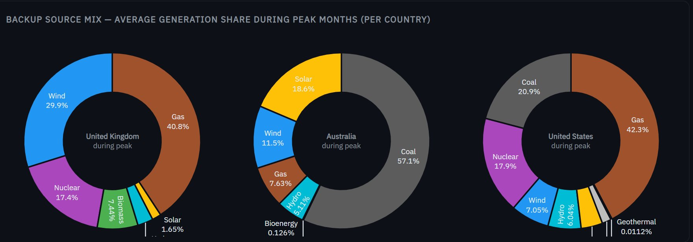
Figure 9. Backup source mix during peak months — UK (winter), Australia (summer), and US (summer). Donut charts show each country's dispatchable backup dependency.
Three observations emerge from Figure 9. First, the UK's peak mix is the most diversified — Gas (40.8%), Wind (29.9%), Nuclear (17.4%), and Biomass (7.4%) form a balanced portfolio where no single source dominates. Second, Australia's peak generation is 57.1% Coal alone — the legacy coal fleet still carries the grid during summer stress, even as Solar contributes 18.6%. Third, the US depends on three fossil sources plus Nuclear, with Gas (42.3%) and Coal (20.9%) together covering nearly two-thirds of peak demand.

Visual analysis — reliability gap over time
Figure 10 plots the reliability gap (non-peak renewable share minus peak renewable share) annually for each country. A positive gap means renewable share drops during peak months; a negative gap means renewable share is actually higher during peak. The orange dashed line at zero is the critical reference point.
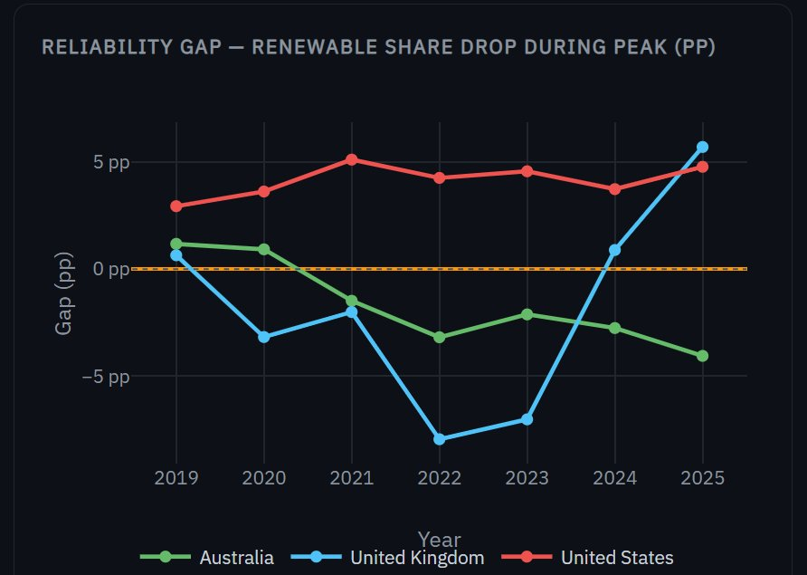
Figure 10. Reliability gap over time — renewable share drop during peak (percentage points). The US consistently runs positive (gap grows during summer); UK and Australia hover around zero or negative.
The US (red line) is consistently above zero across the entire 2019–2025 window — its renewable share always drops during summer peaks because solar output cannot compensate for collapsed wind generation during heatwaves. Australia (green) stays below zero most years: its solar resource is strongest precisely when demand peaks, so renewable share is actually higher in summer than winter. The UK (blue) shows the most volatile behaviour, with sharp dips to −8 pp in 2022–2023 (extreme winter wind shortages) and a jump to +6 pp in 2025.

Visual analysis — fossil dependency trend
Figure 11 shows how fossil share during peak months has evolved year-by-year. Where the reliability gap chart above shows the relative change, this chart shows the absolute fossil dependency level during stress periods.
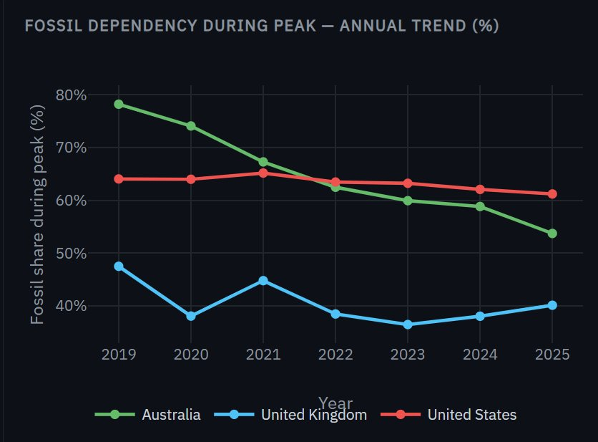
Figure 11. Fossil dependency during peak — annual trend. Australia's peak fossil share fell sharply from 78.2% (2019) to 53.7% (2025); UK stayed below 50%; US declined slowly from 64% to 61%.
Australia's trajectory is the most striking — peak fossil dependency fell from 78.2% in 2019 to 53.7% in 2025, a 24.5 percentage point reduction in just six years. The UK stayed consistently below 50% throughout, reflecting its mature transition. The US declined only marginally from 64% to 61%, confirming that its peak-period fossil lock-in is substantially stronger than the other two grids.

Key findings
Country | Peak season | Renewable (peak) | Renewable (non-peak) | Reliability gap | Primary backup
United Kingdom | Winter (Dec–Feb) | 41.8% | 39.9% | -1.9 pp | Nuclear + Gas
Australia | Summer (Dec–Feb) | 35.2% | 33.5% | -1.7 pp | Coal + Gas
United States | Summer (Jun–Aug) | 17.0% | 21.1% | -4.1 pp | Gas + Coal + Nuclear

- US most vulnerable: The US exhibits the largest reliability gap (−4.1 pp). During summer peaks, renewable share drops from 21.1% to 17.0% while fossil dependency rises to 63.4%. Gas (42.3%) and Coal (20.9%) together cover nearly two-thirds of generation during peak stress (Figure 9).
- UK most resilient: The UK's reliability gap is the smallest (−1.9 pp). Nuclear (17.4% of peak generation) provides stable baseload unaffected by weather, and Wind is often strong in winter months — meaning peak and non-peak renewable shares are nearly equal.
- Australia coal-heavy backup: Despite significant renewable growth, Coal still dominates peak-period generation in Australia (57.1% of peak mix — Figure 9). This reveals the structural persistence of coal as the primary backup even as Solar and Wind expand rapidly.
- Annual trend — improving resilience: All three countries show declining peak-period fossil dependency year-over-year from 2019 to 2025 (Figure 11). Australia's peak fossil share fell from 78.2% to 53.7%, suggesting that growing renewable capacity is gradually reducing stress-period vulnerability even before storage solutions are deployed at scale.

Additional visual analysis — RQ2
Figure 12 presents the renewable share grouped bar chart comparing peak and non-peak months directly. The orange bars (peak months) and blue bars (non-peak months) sit side by side for each country, making the reliability gap immediately visible. The UK and Australia show nearly equal bar heights — their grids perform similarly in both conditions. The US shows a clear difference, with the blue bar exceeding the orange bar, confirming its higher vulnerability during summer stress.
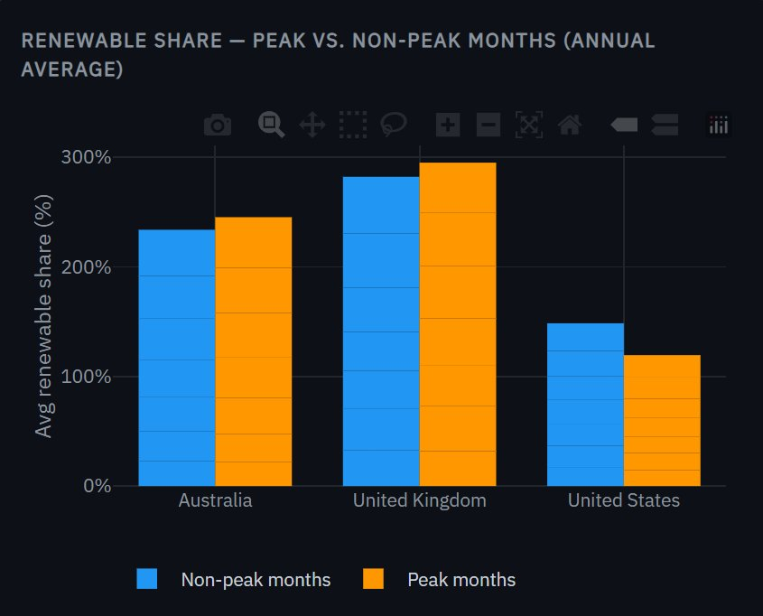
Figure 12. Renewable share — peak vs. non-peak months (annual average). UK and Australia show near-equal bars; the US gap confirms summer stress vulnerability.
Figure 13 shows the monthly renewable share scatter plot with peak months highlighted as large bright dots and non-peak months as faded smaller dots. This granular view reveals patterns that the annual averages cannot capture: the UK's peak months (blue, large) often appear at the top of the distribution — its winter Wind resource is strong. Australia's peak months (green, large) cluster at moderate levels, reflecting the solar/demand alignment in summer. The US peak months (red, large) consistently sit below the non-peak cluster, confirming that every summer is a stress event.
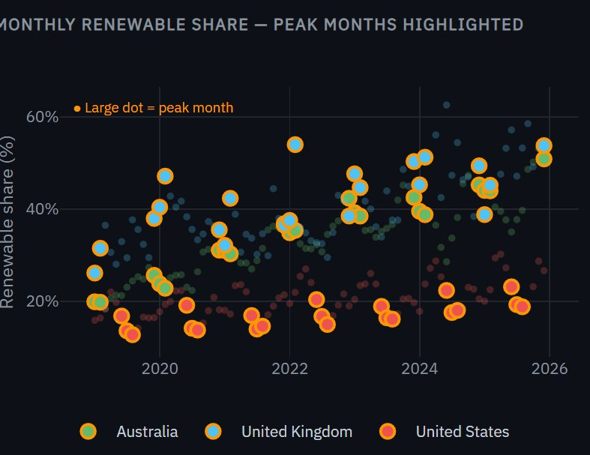
Figure 13. Monthly renewable share — peak months as large bright dots, non-peak as faded dots. US peak months consistently below non-peak; UK peak months often above average.
Figure 14 presents the full backup source breakdown during peak months as a stacked bar chart faceted by country across all years. This chart reveals the year-on-year evolution of the backup mix. In Australia, Coal (grey) shrinks visibly from 2019 to 2025 while Solar (yellow) and Wind (blue) grow — the backup portfolio is diversifying. In the UK, Gas (brown) dominates but Wind (blue) has grown substantially as a peak contributor. The US mix is remarkably stable — Gas and Coal proportions barely change from year to year.
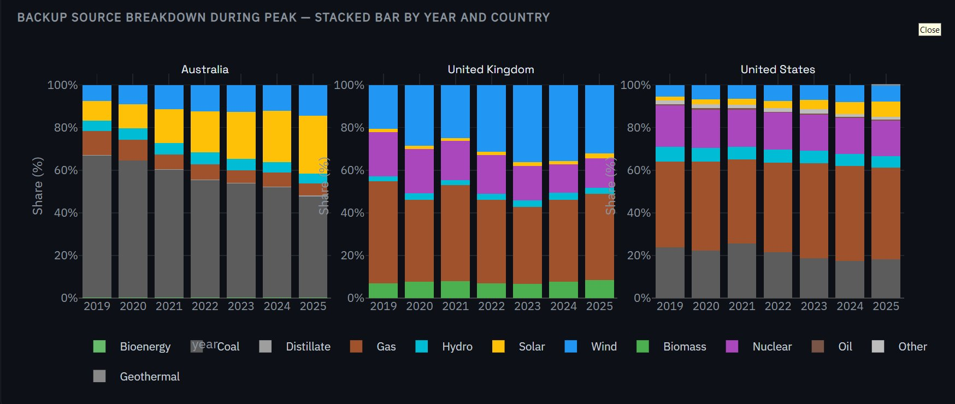
Figure 14. Backup source breakdown during peak — stacked bar by year and country. Australia's mix diversifies visibly; UK grows Wind during peak; US remains structurally frozen.

Visualisations used for RQ2
- Donut charts (Figure 9): Backup source mix during peak months, one donut per country. Chosen over stacked bars because the question is part-of-whole composition — 'what fraction does each source contribute?' Side-by-side placement enables immediate structural comparison across countries.
- Reliability gap line chart (Figure 10): Annual difference (non-peak minus peak renewable share) per country. Line chart was chosen to reveal the temporal trend — is the gap widening or narrowing? The orange dashed zero reference line provides the critical interpretive threshold.
- Fossil dependency trend (Figure 11): Peak-period fossil share tracked annually per country. Complements the relative gap chart with the absolute dependency level, showing that Australia dropped from 78% to 54% during peak periods.
- Peak vs. non-peak grouped bar (Figure 12): Renewable share during peak (orange) and non-peak (blue) months shown side by side per country. The grouped bar idiom makes the reliability gap directly readable as the visual distance between paired bars.
- Monthly scatter with peak highlighting (Figure 13): Individual monthly data points with peak months as large bright markers and non-peak as faded dots. This idiom provides granular evidence behind the aggregate statistics and reveals within-year seasonal patterns that annual averages obscure.
- Backup stacked bar by year (Figure 14): Year-by-year source breakdown during peak months, faceted by country. The stacked bar idiom was chosen to track how the backup mix evolves over time — for example, showing that Coal's share of Australia's peak mix shrinks visibly while Solar and Wind grow.

3.3 RQ3 — Market Volatility

Objective and design rationale
Question: Does a higher share of Solar and Wind make wholesale electricity prices more
volatile and unpredictable? (Australia only — only dataset with price data)

- What we are looking for: Whether renewable penetration is statistically associated with price instability. The hypothesis to test: 'more variable renewables = more price swings.' If true, the scatter plot should show an upward trend; if false, volatility is driven by other factors.
- How we measure volatility: Two metrics are used. Standard Deviation (SD) measures absolute price swings in AUD/MWh. Coefficient of Variation (CV = SD ÷ Mean × 100) measures relative volatility — essential because average prices tripled over the study period, so a rising SD alone could reflect higher price levels, not more instability.
- Why three historical eras: The 26-year dataset is divided into Pre-renewable (1999–2009, W+S ≈0%), Early transition (2010–2016, W+S ≈5%), and High renewable (2017–2025, W+S ≈25%). Comparing distributions across eras tests whether the regime change coincides with higher volatility.
- Why a rolling 12-month SD: Figure 15 uses a rolling window rather than annual aggregates because it captures when volatility regimes shift without being dominated by calendar-year boundaries.
- Why a scatter plot for the core test: The W+S share vs. CV scatter is the critical analytical chart. The scatter idiom was chosen because the hypothesis concerns the relationship between two continuous variables — no other chart type can test this directly.
- Why box plots for era comparison: Box plots show the full price distribution within each era (median, IQR, outliers) — far more informative than comparing era means alone.
- Why an exclude-2022 toggle: 2022 is a confounding outlier driven by the global energy crisis. An interactive toggle lets the analyst test whether the correlation survives without this single dominant event — it does not, weakening the hypothesis significantly.

Approach and justification
Price data is only available for Australia (AEMO monthly wholesale price, AUD/MWh, 1999–2025). Two volatility metrics were computed: Standard Deviation (SD) measures absolute price swings, while Coefficient of Variation (CV = SD ÷ Mean × 100) measures relative volatility — essential because nominal Australian electricity prices tripled over the study period, meaning rising SD alone could simply reflect higher prices rather than more instability. Annual CV was correlated with annual Wind+Solar share to test the core hypothesis. Three historical eras were defined to contextualise the analysis: Pre-renewable (1999–2009), Early transition (2010–2016), and High renewable (2017–2025).

Visual analysis — rolling price volatility
Figure 15 shows the rolling 12-month standard deviation of Australian wholesale electricity prices from 1999 to 2025. This metric acts as a seismograph for market instability — each spike corresponds to a discrete event that destabilised wholesale prices. The pre-2015 period is remarkably flat, with rolling SD rarely exceeding $20 AUD/MWh. Three major spikes punctuate the record: 2017 (South Australia gas crisis), 2019 (drought-driven hydro shortage), and the dominant 2022 peak reaching $120 AUD/MWh — the largest volatility event on record, driven by coal plant outages and global gas price contagion from the Ukraine conflict.
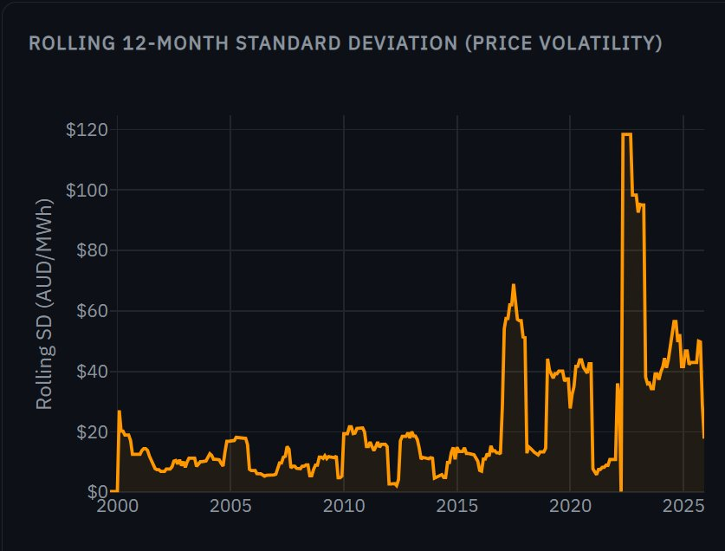
Figure 15. Rolling 12-month standard deviation of Australian wholesale electricity prices (AUD/MWh), 1999–2025. Major spikes in 2017 and 2022 correspond to fossil fuel supply shocks, not renewable intermittency events.

Visual analysis — annual coefficient of variation
Figure 16 presents the annual CV coloured by era — grey for the pre-renewable period (1999–2009), orange for early transition (2010–2016), and blue for the high-renewable era (2017–2025). If renewables systematically caused volatility, the blue bars should be consistently taller than the orange and grey bars. Instead, the pattern is irregular: 2020 (CV = 69%, driven by COVID demand collapse) and 2022 (CV = 57%, energy crisis) are the highest blue bars, but 2010 (CV = 60%, carbon tax uncertainty) in the orange era is comparable. Several blue-era years (2018, 2021, 2025) have lower CV than the pre-renewable baseline.
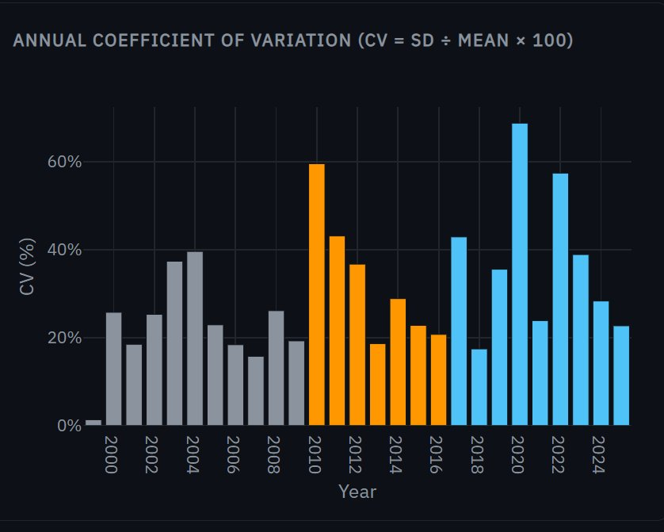
Figure 16. Annual coefficient of variation by era. Grey = pre-renewable (1999–2009), orange = early transition (2010–2016), blue = high renewable (2017–2025). No systematic pattern of higher CV in the high-renewable era.

Visual analysis — emissions intensity co-trend
Figure 17 tracks Australia's emissions intensity (kgCO₂e/MWh) over the full 1999–2025 period. The curve demonstrates that the energy transition is achieving its primary environmental goal: emissions per unit of electricity fell from approximately 1,000 kgCO₂e/MWh in 1999 to roughly 520 kgCO₂e/MWh in 2025 — a 47% reduction. The decline rate accelerates visibly after 2017 (the shaded high-renewable era), coinciding with rapid Wind and Solar deployment. This chart provides important context for the price volatility question: even if prices have become more volatile, the grid is delivering substantially lower-carbon electricity.
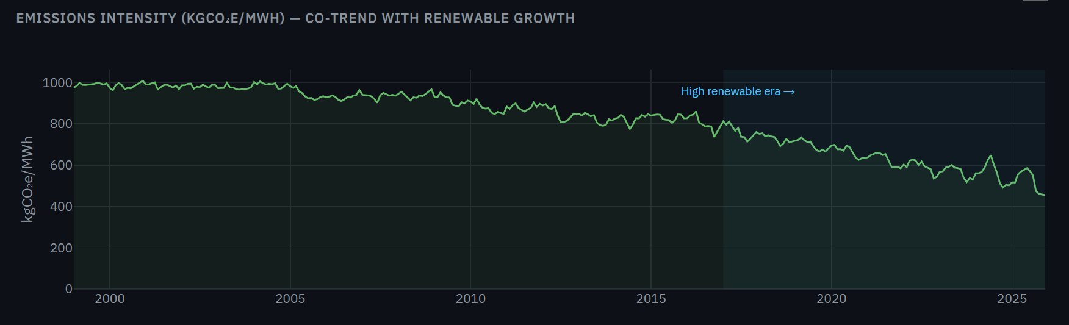
Figure 17. Emissions intensity (kgCO₂e/MWh) for the Australian NEM, 1999–2025. The decline accelerates sharply after 2017, coinciding with the high-renewable era. The shaded region marks the period when Wind+Solar exceeded 10% of generation.

Key findings
Era | Mean price (AUD/MWh) | Std dev | Max price | Avg W+S share
Pre-renewable (1999–2009) | $37.4 | $12.7 | $69.5 | ~0%
Early transition (2010–2016) | $47.7 | $17.4 | $86.3 | ~5%
High renewable (2017–2025) | $100.1 | $52.6 | $317.1 | ~25%

- Prices rose sharply in the high-renewable era: Mean wholesale price more than doubled from the early-transition to the high-renewable era ($47.7 → $100.1 AUD/MWh). Standard deviation also increased substantially ($17.4 → $52.6).
- Weak correlation between W+S share and CV: The correlation between annual Wind+Solar share and annual CV was r = 0.26, indicating a weak positive relationship. This suggests renewable penetration is not the primary driver of price volatility.
- 2022 as a confounding outlier: The 2022 peak of $317.1 AUD/MWh — the highest price on record — occurred during the global energy crisis triggered by Russia's invasion of Ukraine and Australian domestic coal supply disruptions. This event, unrelated to renewable penetration, dominates the statistical picture. Excluding 2022 weakens the correlation further.
- Emissions declining consistently: Emissions intensity (kgCO₂e/MWh) fell from ~975 in 1999 to ~520 in 2025 — a 47% reduction. This decline accelerates after 2017, coinciding with the rapid deployment of Wind and Solar, confirming that the transition is achieving its primary climate goal regardless of price effects.
- Price volatility driven by fuel markets, not renewables: The evidence suggests that fossil fuel market shocks (2007 gas prices, 2017 coal supply tightness, 2022 global crisis) explain most of the observed CV spikes, rather than renewable intermittency. This is consistent with international literature on wholesale electricity market dynamics.

Additional visual analysis — RQ3
Figure 18 presents two panels. The left panel shows the annual Coefficient of Variation (CV) bar chart coloured by era — grey for pre-renewable, orange for early transition, and blue for high renewable. The key observation is that the blue bars are not systematically taller than the orange or grey bars: 2018 and 2021 (blue era) have lower CV than several pre-renewable years (2003, 2004). The right panel shows the annual mean price (bars) and standard deviation (line) on a dual axis. The SD line spikes in 2017, 2019, 2022, and 2024 — all years associated with fossil fuel supply disruptions, not renewable deployment milestones.
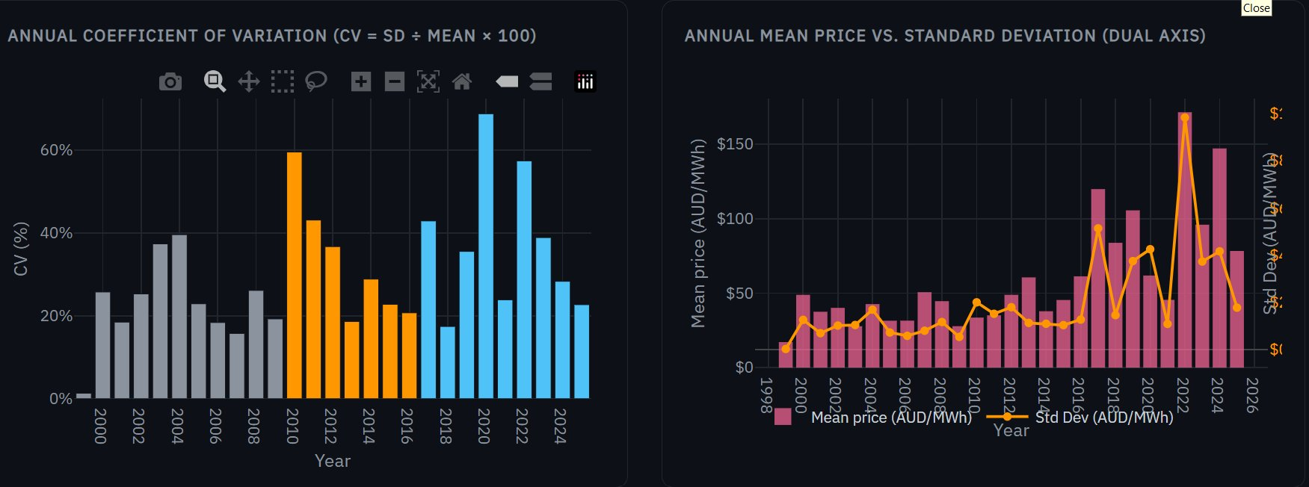
Figure 18. Left: Annual CV by era. Blue (high-renewable) bars are not systematically higher than grey/orange. Right: Annual mean price (bars) vs. standard deviation (line). SD spikes align with fossil supply events.
Figure 19 is the core statistical test for RQ3. Each dot represents one year, plotted by Wind+Solar share (x-axis) against price CV (y-axis). The dots are coloured by era. The dashed pink trend line has R² = 0.07 and slope = 0.32, indicating a very weak positive relationship. Several high-renewable years (2018, 2021, 2025) sit below the trend line with low CV, while pre-renewable years (2003, 2004) sit above it with high CV. The 2020 and 2022 outliers — both driven by external shocks (COVID and energy crisis) — dominate the scatter and inflate the trend.
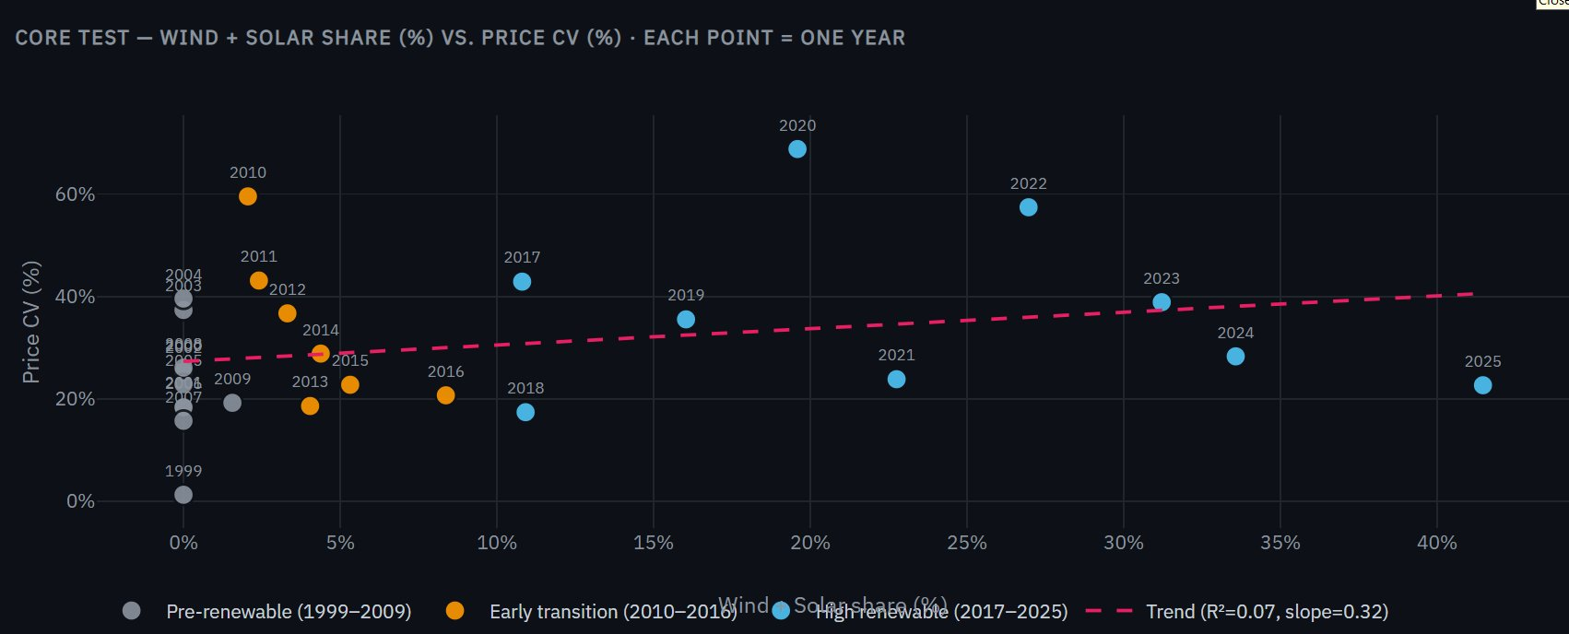
Figure 19. Core test — Wind+Solar share vs. price CV. R² = 0.07, slope = 0.32. Weak positive relationship; outliers (2020, 2022) driven by external shocks inflate the trend.
Figure 20 presents two complementary panels. The left panel shows price distribution by era as box plots. The pre-renewable era (grey) has the tightest distribution ($30–$70). The early-transition era (orange) is slightly wider. The high-renewable era (blue) shows a dramatically wider range ($50–$200+) with the $317 outlier visible. However, the median of the high-renewable era ($95) is only modestly above the early-transition median ($55) — the extreme range is driven by a few spike events, not by systematic instability. The right panel overlays Wind+Solar share growth (blue, rising steadily) with mean price (pink, volatile) on a dual axis, demonstrating that price movements do not track renewable deployment — they spike and recover independently of the renewable curve.
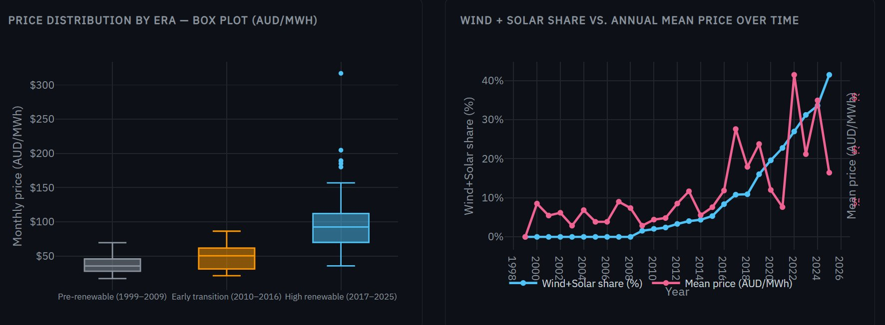
Figure 20. Left: Price distribution by era (box plot). High-renewable era has wider range but median only modestly higher. Right: W+S share vs. mean price over time — price volatility is independent of the renewable growth curve.

Visualisations used for RQ3
- Rolling 12-month SD area chart (Figure 15 / RQ3): Smoothed volatility signal using a 12-month rolling standard deviation. The area fill emphasises the magnitude of volatility spikes. Chosen over annual aggregates because it captures exactly when volatility regimes shift — the three major spikes (2017, 2019, 2022) are clearly identifiable as discrete events.
- Annual CV bar chart (Figure 16 / RQ3): Year-by-year CV coloured by era (grey = pre-renewable, orange = early transition, blue = high renewable). The colour encoding provides immediate visual grouping — readers can scan for whether blue bars are systematically taller than grey/orange bars (they are not).
- Annual CV and SD vs. Mean dual panel (Figure 18): Left panel shows CV bars by era; right panel shows mean price (bars) with SD (line) on a dual axis. The dual-axis idiom was chosen to test whether SD rises simply track higher prices — the divergence between bars and line in 2022 confirms that the spike is disproportionate.
- Core scatter — W+S share vs. CV (Figure 19): The critical statistical chart for RQ3. Each point is one year, coloured by era. The dashed trend line reports R² = 0.07 and slope = 0.32. The scatter idiom is the only chart type that can directly test the relationship between two continuous variables. Era colouring reveals that high-CV outliers come from all three eras, not just the renewable era.
- Era box plot and dual trend (Figure 20): Left: price distribution within each era as box plots. Box plots were chosen over means because they show the full distribution — median, IQR, and outliers — revealing that the high-renewable era has a wider range but only a modestly higher median. Right: W+S share (rising steadily) vs. mean price (volatile) on dual axes, demonstrating the independence of the two variables.
- Emissions intensity line chart (Figure 17 / RQ3): Monthly kgCO₂e/MWh from 1999 to 2025 with the high-renewable era shaded. Provides essential context: even if prices became more volatile, emissions fell 47% — the transition is achieving its primary environmental goal.

3.4 RQ4 — Energy Portfolio Diversification

Motivation and research objective
RQ1 measured the speed of decarbonisation and RQ2 tested grid resilience during peak stress. However, neither question addresses a deeper structural concern: is the energy transition producing a healthier, more balanced generation portfolio — or merely replacing one dominant fuel with another? A grid that shifts from 70% coal to 70% solar may score well on carbon metrics, but remains structurally fragile. A single technology disruption — prolonged cloud cover, a panel supply-chain failure, or a policy reversal — could destabilise the entire system. RQ4 therefore asks:

RQ4: Is the energy transition making electricity grids structurally more diverse and resilient,
or simply swapping one dominant fuel for another?

The goal is to quantify whether each country's generation mix is becoming more balanced over time, and whether decarbonisation mechanically produces diversification or whether a country can decarbonise without diversifying. This distinction has direct policy relevance: a diversified grid is inherently more resilient to supply shocks, fuel price spikes, and technology-specific disruptions, regardless of its carbon intensity.

Key terminology
This analysis borrows two metrics from competition economics and adapts them to electricity generation:

- Herfindahl-Hirschman Index (HHI): A market concentration metric calculated as the sum of squared market shares, scaled to a 0–10,000 range. In its original use, regulators (such as the U.S. Department of Justice) apply HHI to assess whether a merger would create a monopoly. Here, each energy source is treated as a 'firm' and its share of total monthly generation is its 'market share.' An HHI of 10,000 means one source produces 100% of electricity (monopoly). An HHI below 2,500 indicates a diversified mix. Between 2,500 and 4,500 is moderately concentrated. Above 4,500 is highly concentrated. The formula is: HHI = ∑(share_i²) × 10,000, where share_i is the fractional contribution of source i to total generation.
- Effective Number of Sources (ENS): An intuitive transformation of HHI defined as ENS = 10,000 ÷ HHI. If a grid has six sources but one dominates at 70%, the ENS might be only 2.1 — meaning the grid behaves as if it has just two equally-sized sources. If all six sources contributed equally (~16.7% each), the ENS would be 6.0. A rising ENS over time indicates genuine structural diversification, not just a token addition of minor sources.
- Top source dominance: The share of total generation contributed by the single largest source in each country-year. A declining top-source share confirms that diversification is real — the dominant fuel is losing its grip, not just being joined by marginal contributors.
- Diversification speed: The slope of a linear regression fitted to the monthly HHI time series for each country. A more negative slope means faster diversification. This metric is directly analogous to the transition velocity (regression slope on fossil share) computed in RQ1, enabling a consistent cross-country comparison.

Approach and justification
HHI was computed for each country-month from the combined dataset. The same combined_energy.csv used for RQ1 and RQ2 provides the input data, requiring no additional data collection. For each month, the generation_gwh values for all sources present in a country were summed to give the total, then each source's share was squared and summed. The HHI was tracked as a monthly time series with linear regression trend lines overlaid. Annual averages of HHI, ENS, and top-source share were computed for summary tables. A scatter plot of monthly HHI against monthly fossil share was constructed to test whether decarbonisation mechanically produces diversification — if the two are correlated, then reducing fossil dependence simultaneously improves structural resilience.

Visual analysis — diversification speed and top source dominance
Figure 21 presents two panels side by side. The left panel shows the diversification speed — the linear regression slope of monthly HHI for each country. Australia's bar extends to −18.7 HHI points per month, dwarfing the UK (−5.1) and the US (essentially zero). The right panel tracks the share of the single largest source per country over time. Australia's dominant source (Coal) dropped from 66% in 2019 to 50% in 2025 — a 16 percentage point decline in dominance. The UK's dominant source (Gas) declined from 46% to 35%. The US's dominant source (Gas) remained flat at ~40% across the entire window, confirming that its grid structure is frozen despite modest compositional changes.
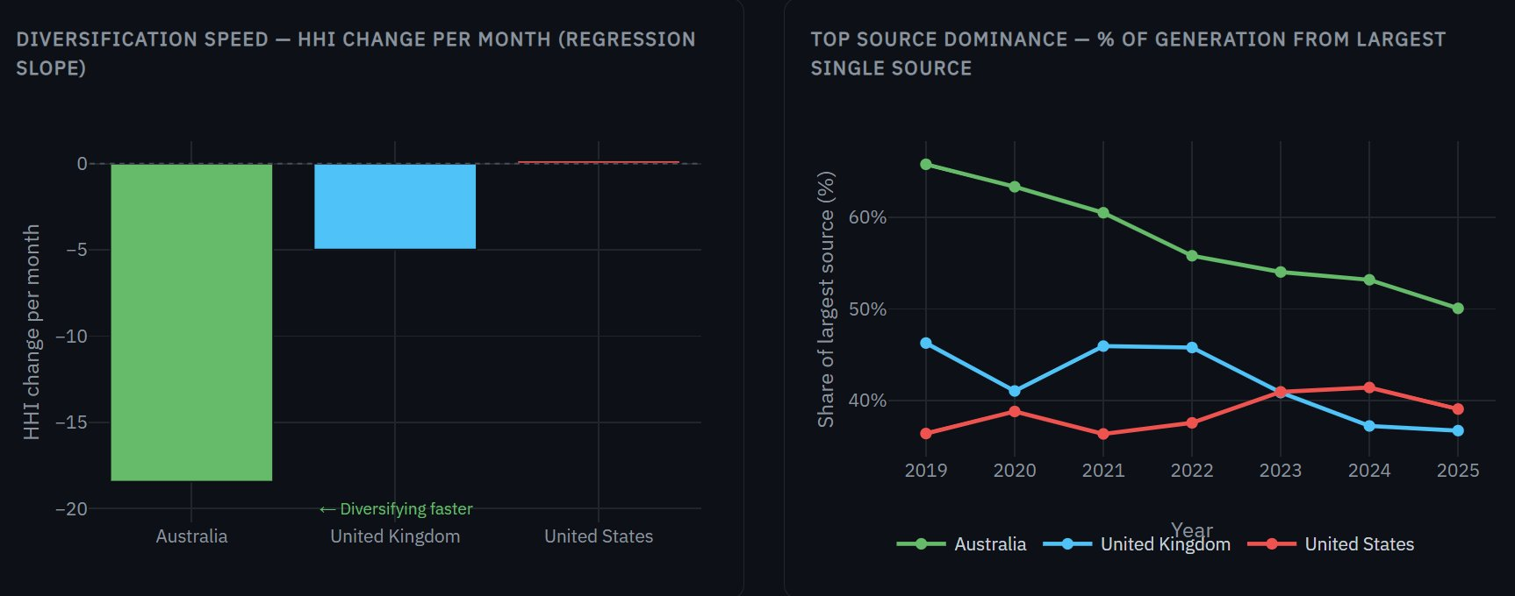
Figure 21. Left: Diversification speed (HHI change per month). Australia diversifies 3.7× faster than the UK and effectively infinitely faster than the static US. Right: Top source dominance declining over time — Australia's Coal dropped from 66% to 50%; UK Gas from 46% to 35%; US Gas stable at ~40%.

Visual analysis — does decarbonisation drive diversification?
Figure 22 is the most analytically important chart in this section. Each dot represents one country-month, plotted by its fossil share (x-axis) against its HHI concentration index (y-axis). Dashed lines show per-country linear regression fits. The pattern is strikingly clear: for all three countries, months with higher fossil share have higher HHI (more concentrated), and months with lower fossil share have lower HHI (more diverse). This establishes a direct structural link between decarbonisation and diversification.
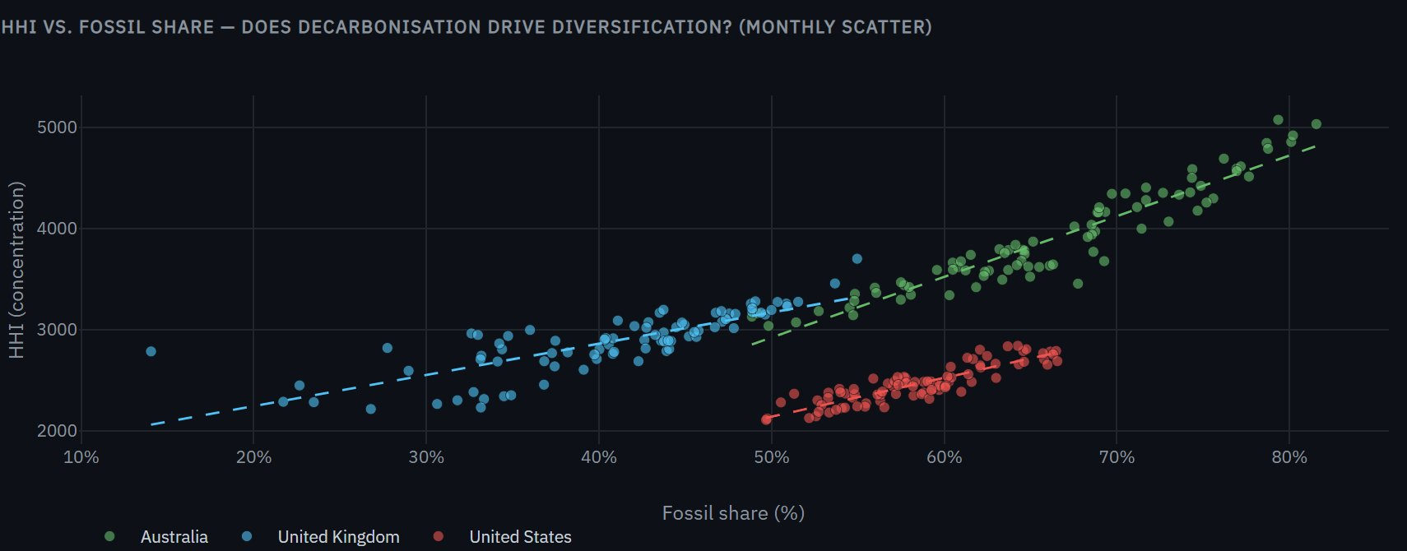
Figure 22. HHI vs. fossil share — monthly scatter with per-country trend lines. Strong positive correlation across all three countries confirms that reducing fossil dependence mechanically increases portfolio diversity. Australia (green) spans the widest range, reflecting its rapid transition from 80% to 50% fossil.

Three observations emerge from Figure 22. First, Australia (green) spans the widest x-axis range (50–80% fossil), reflecting the magnitude of its transition. Its trend line has the steepest slope, meaning each percentage point of fossil reduction yields a larger diversity gain than in the other two countries — because Australia is displacing a single dominant source (Coal) with multiple smaller ones (Solar + Wind + Gas). Second, the UK (blue) occupies a lower and narrower band (15–55% fossil), with a similarly strong positive slope. Its diversity improvements come from Gas declining while Wind and Nuclear maintain stable shares. Third, the US (red) clusters in a tight blob around 55–65% fossil and HHI 2,000–2,900 — confirming that the US grid is structurally stagnant. Its trend line is nearly flat, meaning that the modest fossil share decline it has achieved is not translating into meaningful diversity improvements.

Key findings
Country | HHI 2019 | HHI 2025 | Δ HHI | Slope (pts/mo) | ENS 2019 | ENS 2025 | Dominant source
Australia | 4,650 | 3,362 | −1,288 | −18.7 | 2.2 | 3.0 | Coal (66% → 50%)
United Kingdom | 3,071 | 2,627 | −444 | −5.1 | 3.3 | 3.8 | Gas (46% → 35%)
United States | 2,481 | 2,391 | −90 | +0.2 | 4.0 | 4.2 | Gas (stable ~40%)

- Australia diversifying fastest: Australia's HHI dropped by 1,288 points (from 4,650 to 3,362), moving from 'highly concentrated' to 'moderately concentrated' territory. Its ENS rose from 2.2 to 3.0 — the grid evolved from a de facto two-source system (Coal + everything else) to a genuine three-source mix (Coal + Solar + Wind). The HHI slope of −18.7 points per month is 3.7× faster than the UK's diversification rate.
- UK steadily broadening: The UK entered 2019 with a moderately concentrated grid (HHI = 3,071) dominated by Gas at 46%. By 2025, Gas declined to ~35% while Wind rose to match it, producing a more balanced portfolio with HHI = 2,627 and ENS = 3.8. The UK is approaching the 'diversified' threshold of HHI < 2,500.
- US already diverse but structurally frozen: The US started as the most diverse grid (HHI = 2,481, ENS = 4.0) thanks to its established mix of Gas, Coal, Nuclear, and Wind. However, its HHI barely changed (slope = +0.2 pts/month), meaning the transition is not making the US grid more or less diverse — it is structurally frozen. Gas remains dominant at ~40% across the entire window. This is a paradoxical finding: the US is the most diverse but the least dynamic.
- Decarbonisation drives diversification: The scatter plot (Figure 22) demonstrates a strong positive correlation between fossil share and HHI across all three countries. The displacement of a dominant fossil fuel mechanically increases diversity, because the replacing sources (Wind + Solar) enter at smaller individual shares. This finding has a policy implication: investing in renewable deployment achieves two goals simultaneously — lower carbon intensity and higher structural resilience.

Additional visual analysis — RQ4
Figure 23 presents the HHI concentration index (left) and Effective Number of Sources (right) as monthly time series. The left panel includes colour-coded background bands: green (HHI < 2,500 = diversified), amber (2,500–4,500 = moderate), and red (> 4,500 = concentrated). Australia's green line starts in the red zone and descends into the amber zone by 2024. The UK's blue line stays in the amber zone but trends toward the green boundary. The US red line sits at the amber-green border throughout — structurally flat. The right panel shows ENS, which mirrors HHI inversely: Australia rises from 2.0 to 3.0+, the UK from 3.0 to 3.5+, while the US oscillates around 4.0 without a clear trend.
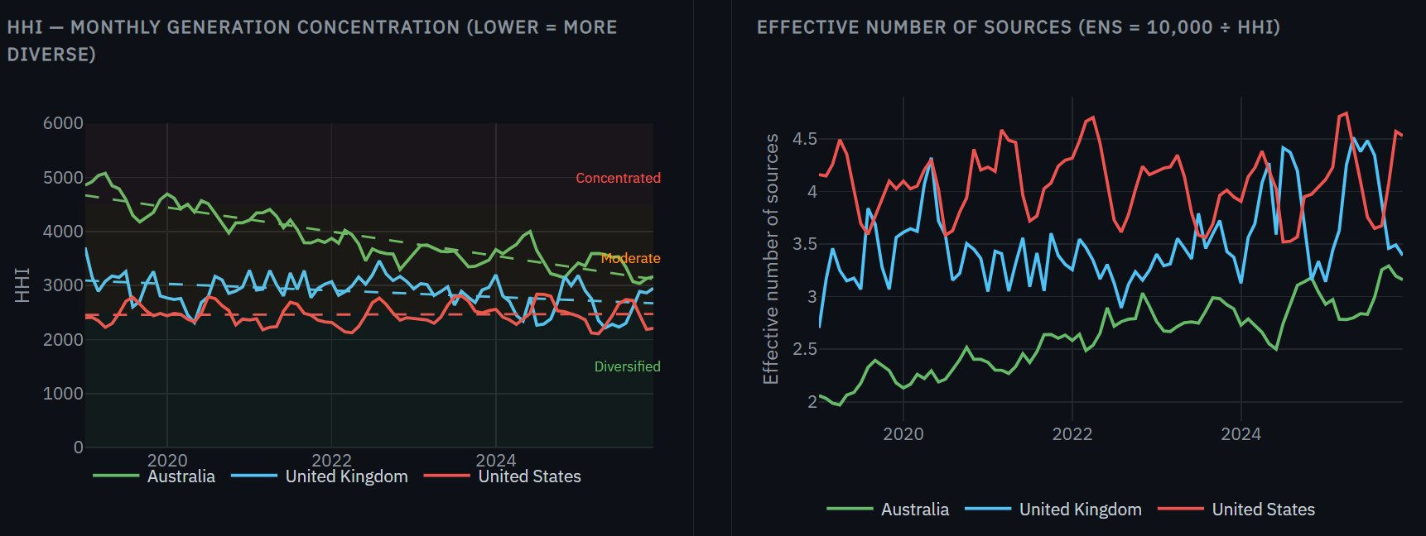
Figure 23. Left: Monthly HHI with concentration bands. Australia descends from concentrated (red) to moderate (amber). Right: Effective Number of Sources — Australia gains one full effective source over the window.
Figure 24 shows the annual source share evolution as stacked bars faceted by country. This chart reveals exactly which sources are gaining and losing share. In the UK (left), Wind (blue) grows dramatically while Gas (brown) shrinks — Nuclear (purple) and Biomass (green) remain stable anchors. In the US (centre), the mix is remarkably static — Gas and Coal proportions barely shift year to year. In Australia (right), the Coal (grey) block shrinks visibly while Solar (yellow) and Wind (blue) expand from thin slivers in 2019 to substantial segments by 2025. This visual evidence directly supports the HHI finding: Australia's diversification is driven by multiple new sources entering simultaneously, not by a single replacement.
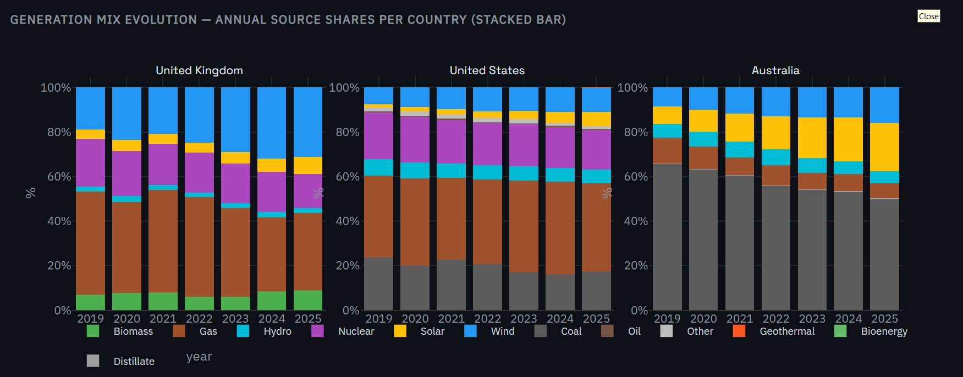
Figure 24. Generation mix evolution — annual source shares (stacked bar per country). UK: Wind replacing Gas. US: static. Australia: Coal shrinking, Solar+Wind growing simultaneously.

Visualisations used for RQ4
- Diversification speed bar chart (Figure 21, left): HHI regression slope per country. Negative = diversifying. The bar chart idiom enables direct comparison of a single scalar metric. The zero reference line and directional annotation ('← Diversifying faster') guide interpretation. Analogous to RQ1's transition speed chart (Figure 5).
- Top source dominance line chart (Figure 21, right): Annual share of the largest single source per country. A declining line confirms that the dominant fuel is genuinely losing its grip — critical evidence that diversification is real, not just a rebalancing among minor sources.
- HHI vs. fossil share scatter (Figure 22): The critical analytical chart for RQ4. Monthly data points coloured by country with per-country linear trend lines. The scatter idiom reveals the causal relationship — 'does reducing fossil share lower HHI?' Each country's cluster position, spread, and slope tell a distinct structural story.
- Monthly HHI and ENS dual panel (Figure 23): Left: HHI time series with background concentration bands (green/amber/red). Dashed trend lines overlay raw monthly data. The colour-coded bands provide immediate context. Right: ENS (10,000 ÷ HHI) — more intuitive than raw HHI because readers immediately understand '3.0 effective sources.'
- Generation mix evolution stacked bar (Figure 24): Annual source shares faceted by country. The stacked bar idiom shows both the total (always 100%) and the internal composition shifting. Confirms that Australia's diversification is driven by multiple sources (Solar + Wind) entering simultaneously, not by a single replacement.

4. Conclusion
This project set out to answer four questions about the global energy transition. The data provided clear answers to three and a nuanced answer to the fourth.

RQ1 is answered decisively: Australia transitioned fastest, recording a fossil share decline of 0.289 percentage points per month and a Wind+Solar gain of 0.298 pp/month from 2019 to 2025 — approximately 8× faster than the US on fossil decline (Figure 5). The UK maintained a steady transition from an already-lower fossil base. The US moved slowest, reflecting structural and political barriers that short analysis windows cannot overcome.

RQ2 revealed that all three grids remain fossil-dependent during peak stress, but to varying degrees. The UK is most resilient (reliability gap of just 1.9 pp, Figure 10), supported by Nuclear as firm baseload. The US is most vulnerable (gap of 4.1 pp), with Gas and Coal covering 63.4% of peak generation (Figure 9). Australia's backup mix remains coal-dominated despite rapid renewable growth, though year-on-year improvement is measurable (Figure 11).

RQ3 produced the most nuanced finding: the correlation between Wind+Solar penetration and price volatility in Australia is weak (r = 0.26), and the dominant volatility events are attributable to fossil fuel market shocks rather than renewable intermittency. The 2022 energy crisis provides a stark natural experiment — price volatility spiked to its highest level precisely when global gas and coal markets were most stressed, not when renewables were highest.

RQ4 revealed an important structural benefit of the transition that RQ1 alone could not capture: Australia's grid is not merely decarbonising — it is diversifying. Its HHI fell by 1,288 points (the equivalent of gaining one full effective source), transforming a coal-dominated monoculture into a genuine multi-source grid. The UK followed a similar pattern at a slower pace. The US, despite being the most diverse grid in absolute terms, is structurally frozen — its diversity is not improving. This finding has direct policy implications: a diversified grid is inherently more resilient to supply shocks, fuel price spikes, and technology-specific disruptions.

5. Reflection
The most important lesson from this project is that data wrangling consumes the majority of effort and that datasets from official sources are far from clean. The readr type coercion bug in the US dataset, the 4 million duplicate rows, the 2,888 sensor dropout readings in GridWatch, and the leading whitespace on every UK timestamp were all invisible until explicitly investigated. A key principle that emerged: never trust that a dataset is clean because it comes from a government agency — always verify programmatically.

On visualisation, the decision to use interactive Shiny dashboards rather than static figures was vindicated by the exploration process: the ability to filter by country, adjust year ranges, and toggle trend lines repeatedly revealed patterns that would have been missed in fixed charts. The addition of RQ4 and the HHI metric demonstrated the value of applying analytical tools from adjacent fields — economics in this case — to energy data. In hindsight, a greater investment in annotation — labelling specific events (2022 energy crisis, the UK coal closure date, Australia's policy inflection points) directly on the charts — would have made the findings more self-explanatory to a general audience.

A limitation of the project is the absence of price data for the UK and US, which constrains RQ3 to Australia alone. Future work could incorporate UK Balancing Mechanism data from Elexon and US day-ahead market prices from CAISO or PJM to enable a genuine cross-country price volatility comparison. Additionally, sub-monthly granularity (hourly or daily prices) would allow a much more rigorous test of the renewable-volatility hypothesis, as monthly averages smooth out the intraday price swings that drive retailer and consumer risk.

6. Bibliography

Data Sources
[1] GridWatch, "GB National Grid Live Status," Templar Consultants Ltd., 2025. [Online]. Available: https://gridwatch.templar.co.uk. [Accessed: Apr. 19, 2026].

[2] U.S. Energy Information Administration, "Hourly Electric Grid Monitor," U.S. Department of Energy, Washington, DC, 2025. [Online]. Available: https://www.eia.gov/electricity/gridmonitor. [Accessed: Apr. 19, 2026].

[3] Australian Energy Market Operator and OpenNEM, "NEM All Regions Generation and Price Summary," AEMO, Melbourne, Australia, 2025. [Online]. Available: https://opennem.org.au. [Accessed: Apr. 19, 2026].

Software and R Packages
[4] H. Wickham et al., "Welcome to the tidyverse," J. Open Source Softw., vol. 4, no. 43, p. 1686, 2019. doi: 10.21105/joss.01686.

[5] G. Grolemund and H. Wickham, "Dates and Times Made Easy with lubridate," J. Stat. Softw., vol. 40, no. 3, pp. 1–25, 2011. doi: 10.18637/jss.v040.i03.

[6] S. Firke, "janitor: Simple Tools for Examining and Cleaning Dirty Data," R package version 2.2.0, 2023. [Online]. Available: https://CRAN.R-project.org/package=janitor.

[7] C. Sievert, Interactive Web-Based Data Visualization with R, plotly, and shiny. Boca Raton, FL: CRC Press, 2020. [Online]. Available: https://plotly-r.com.

[8] W. Chang et al., "shiny: Web Application Framework for R," R package version 1.8.0, 2023. [Online]. Available: https://CRAN.R-project.org/package=shiny.

[9] T. Kalinowski and D. Vaughan, "slider: Sliding Window Functions," R package version 0.3.1, 2023. [Online]. Available: https://CRAN.R-project.org/package=slider.

[10] H. Wickham, M. Çetinkaya-Rundel, and G. Grolemund, R for Data Science, 2nd ed. Sebastopol, CA: O’Reilly Media, 2023. [Online]. Available: https://r4ds.hadley.nz.

Domain Literature
[11] D. Newbery, M. G. Pollitt, R. A. Ritz, and W. Strielkowski, "Market Design for a High-Renewables European Electricity System," Renew. Sustain. Energy Rev., vol. 91, pp. 695–707, Aug. 2018. doi: 10.1016/j.rser.2018.04.025.

[12] L. Hirth, "The Market Value of Variable Renewables: The Effect of Solar and Wind Power Variability on Their Relative Price," Energy Econ., vol. 38, pp. 218–236, Jul. 2013. doi: 10.1016/j.eneco.2013.02.004.

[13] International Renewable Energy Agency, Renewable Power Generation Costs in 2022. Abu Dhabi: IRENA, 2023. [Online]. Available: https://www.irena.org/publications/2023/Aug/Renewable-Power-Generation-Costs-in-2022.

[14] National Grid ESO, Future Energy Scenarios 2024. Warwick, U.K.: National Grid ESO, 2024. [Online]. Available: https://www.nationalgrideso.com/future-energy/future-energy-scenarios.

